Date of issue : 01 Januari 2020
Quotation number : 001/QS-SI/GH/I/2020
Handled by : Amir Djaya
Phone number : 081 7123 4567
Email : amirdjaya@sanmaind.com

____________________________________________________________________________
Attention: Dear Sir/Madam Underwriter
QUOTATION SLIP TO INSURER

Please provide us with your quotation based on the following term & condition:

Type of Insurance : Group Health Insurance

Insured : PT. XXX

Address : Jl. Petojo VIY III.21
Cideng – Gambir, Jakarta Pusat 15430

Line of Business : Banking

Insured : Employee only

Insurance Period : 01 Januari 2020 – 31 Desember 2020

Scope Of Coverage : National coverage, 365 days, 24 hours

Total Number of Insured : 300 persons (as per member list received on 01 Januari 2020) with demography as follow:
Benefit | IP 1500 | IP 1200 | IP 1000 | IP 900 | IP 800 | IP 700 | IP 500 | IP 400 | Total
Employee | 10 | 10 | 10 | 10 | 10 | 10 | 10 | 230 | 300
Male | 5 | 5 | 5 | 5 | 5 | 5 | 5 | 180 | 205
Female | 5 | 5 | 5 | 5 | 5 | 5 | 5 | 70 | 95

Coverage Option :
- Inpatient
- Outpatient
- Maternity
- Dental

Limit of Indemnity : as per benefit table on page x

Conditions/extensions : as per term and condition attached (page x)

Exclusion :
- Aaaaaa
- Bbbbbb
- Cccccc
- Ddddddd

Premium : IDR

Broker Fee : 15% excluding VAT 10%

Premium Payment Term : Annually

Premium Payment Warranty : 60 days after inception date

Historical Insurer :
- 01/01/2018 – 31/12/2018 by MSIG Sinar Mas
- 01/01/2019 – 31/12/2019 by Allianz

Claims information : Claim ratio by Allianz 28% (paid as per data received from insurer as per 31 Okt 2019 IDR 34.450.600)

Validity of Quotation : 60 days

Your faithfully,

SANMA INDONESIA

INSURER CONFIRMATION - 001/QS-SI/GH/I/2020

Insured’s name : PT. XXX

Insurance’s name : _____________________________

Authorized name : _____________________________

Sign & Stamp :

__________________

Attachment of 001/QS-SI/GH/I/2020

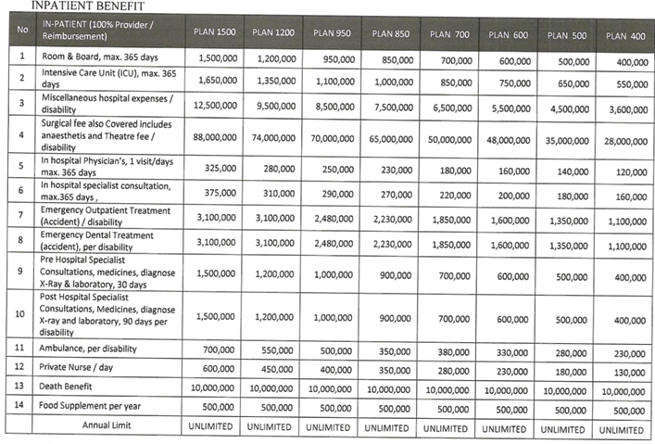

TERM AND CONDITION

No | Membership | Confirmation
1 | Automatic Addition Deletion 30 days
2 | Addition member: prorated premium (prorate days) with fully benefits will apply (all benefits)
3 | Deletion member: refund premium (prorate days 100% premium) with prorate calculation regardless history for the termination member
4 | To waived endorsement administration charges and stamp duty
5 | To waived charges for re-print (re-issue) of membership if mistaken from insurance and lost/broken by member
6 | Eligibility age: up to 59 yo for new entry and up to 64 yo for renewal member
7 | Membership card for each member
8 | Standard handbook is required and provided for each member (including employee addition)

No | General Condition | Confirmation
9 | Waived 'pre- existing' conditions for all member (existing and new member) to all benefit cover
10 | Waived 'waiting period' to all benefit cover
11 | Socialization is available 1 time within Jabodetabek Area
12 | To cover Vitamin, Multivitamin and Food Supplement
13 | To cover Work related injuries and sickness
14 | To cover participation of hazardous sports and activities (unprofessional)
15 | To Cover Death Benefit due to any cause for all member
16 | To Cover administration charges
17 | Reinstatement for same illness : 7 days after discharged from hospital
18 | Quarterly member changes data report is available
19 | Quarterly claim report detail includes top 20 diagnose, 20 claimants and the most 20 provider usage
20 | Available to reconcile data and premium if needed

No | Claims | Confirmation
21 | All excess occurred in hospital will be settled first by Insurer and then to be charge through company, for exclusion, excess limit, using higher room and board above the room and board tolerance including due to own willingness. The company must settle within maximum 30 days after the excess invoice date
22 | Reimbursement claim process is max. 10 working days
23 | Reimbursement claim payment: transfer to company's bank account without bank charges
24 | Claim system: cashless at provider network and reimbursement at non-provider network
25 | Validity of Reimbursement Claim Documents for all benefit is 90 calendar days after discharged from hospital and/or date of treatment, with re-claim 90 calendar days

No | Inpatient Benefit | Confirmation
26 | Benefit coverage is Inner Limit, cashless in provider and non-provider network
27 | Limitation of room and board maximum 365 days;
28 | ICCU, HCU, HDU, NCU, PICU, NICU, Intermediary room, isolation room under ICU benefit limit with maximum 365 days;
29 | In hospital physician benefit limit per day,per day, max. 365 days
30 | In hospital specialist consultation benefit limit per day max. 365 days
31 | To cover medicine, test diagnostic, hospital administration charges, stamp duty, physiotherapy during hospitalization under Miscellaneous benefit limit per confinement
32 | Surgical benefit per disability, including surgeon's fee, anesthetist's fee and operating theatre
33 | To Cover Medicines and medical tools used in operating theater when undergoing a surgery under surgery limit
34 | To cover Ambulance related treatment to hospital and from hospital to other
35 | Pre hospitalization covered for doctor consultation, prescribed medicines and lab test diagnostics 31 days prior to hospitalized
36 | Post hospitalization covered for doctor consultation, prescribed medicines and lab test diagnostics 90 days after hospitalized
37 | To cover emergency outpatient treatment due to emergency condition and accident (Sickness and accident) within 2x24 hours with 31 days' continuous treatment
38 | To cover emergency dental treatment due to accident within 2x24 hours with 31 days' continuous treatment
39 | In hospital Private Nurse benefit limit per day maximum 365 days
40 | To cover medical appliances (prosthesis), limited to Pen, Stent, Ring, Plate, Screw, K-Wire, IOL, ESWL, stapler, pace maker and brace under miscellaneous limit
41 | To cover Chemotherapy and Dialysis (acute condition and follow up/routine treatment) when treatment received as inpatient (there is room and board charges from hospital) under miscellaneous limit
42 | To cover One Day Care/Surgery (ODS) under surgery limit
43 | Hospital Cash Plan benefit for admission of more than 24 hours. Such benefit will be paid for the full duration of hospitalization is member is admitted following BPJS procedure and being admitted to BPJS provider without any claim to commercial insurer. Maximum up to 365 days.
44 | To cover Administration under miscellaneous limit, including stamp duty
45 | To cover Hernia disease without age limitation, as long as not related to congenital
46 | Minimum hours for inpatient is 6 hours, subject to medical indication and room charge from hospital
47 | Room Tolerance: Due to unavailability or fully book room: In case of original entitled room is not available, the member can upgrade up to 25% or IDR 100,000 for until discharge.  If the member upgrade room & board due to his/her own willingness, excess will be calculated from the 1st day of treatment
48 | To Cover Auto-Immune Disease such as Lupus, Psoriosis, etc

